TASK 2

Three phase motor connected to full-voltage magnetic starter controlled by stop and start push button station with indicating light's ss stop (idle) and start (rmn).

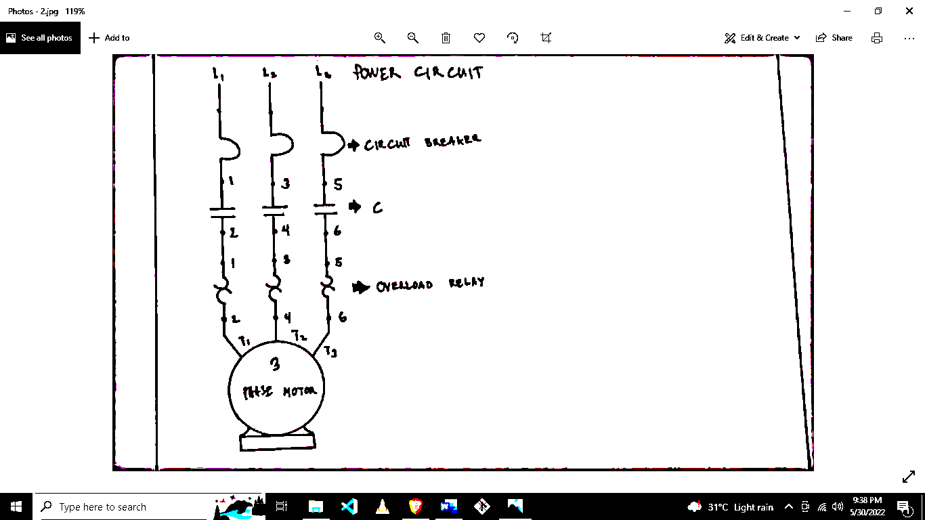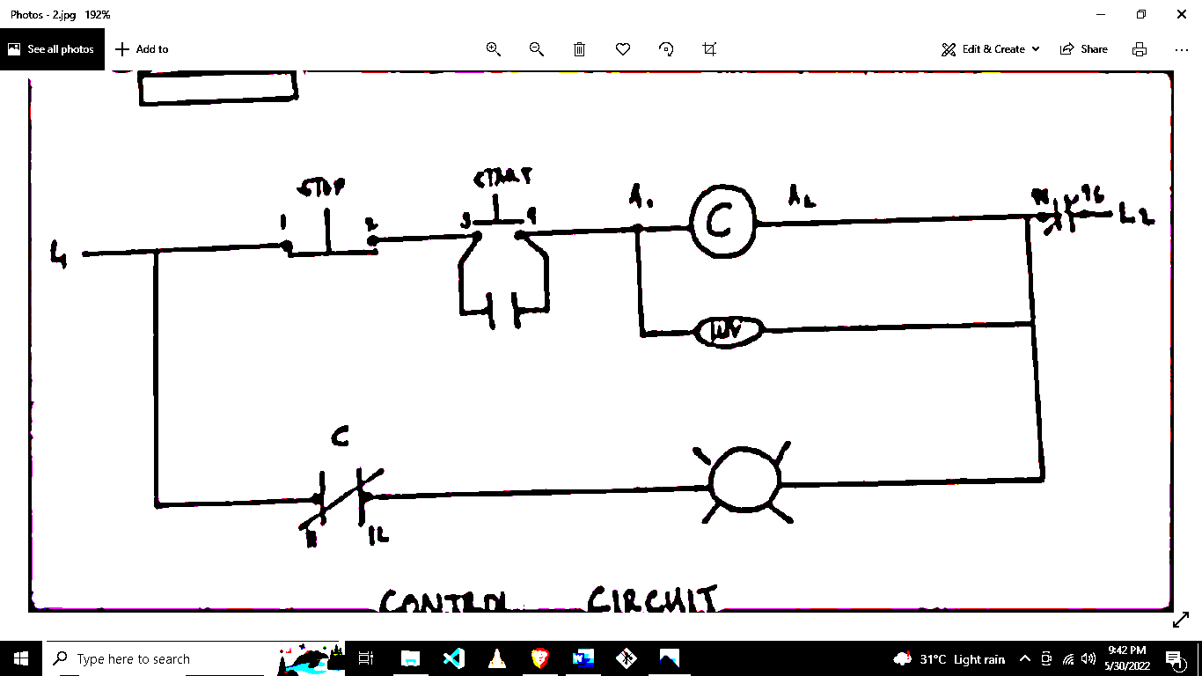

Power Circuit

Overload Relay

C

Circuit Breaker

Control Circuit